
COMSATS University Islamabad, Lahore campus
Assignment #2
Software Requirements Engineering
Submitted To:
Dr. Ghulam Rasool
Submitted by:
Samiullah Ashfaq
Sp24-BSE-107
Zain Yaqoob
Sp24-BSE-125
Muhammad Aqib Javed
Sp24-BSE-150
Section: A

Task 1: Requirements Analysis and Problem Identification
After carefully reviewing the requirements elicited in Assignment 1, we identified several issues. These problems fall under common requirement defects discussed in class: ambiguity, incompleteness, inconsistency, and non-verifiability. The table below lists each problematic requirement, describes the issue, and provides an updated corrected version.

# | Original Requirement | Problem Identified | Updated Requirement
1 | User registration and confirmation of enrollment at the university. | Ambiguous — does not specify how enrollment is confirmed (document upload, university API, manual check?) or which universities are in scope. | The system shall allow students to register by uploading a valid university ID or enrollment letter. Where available, the system shall integrate with university student portals for automated verification.
2 | Ride reservation and scheduling for car/bike pooling. | Incomplete — no mention of advance booking window, seat capacity limits per ride type, or what happens if a booking slot fills up before confirmation. | Students may book or schedule rides up to 24 hours in advance. Cars support a maximum of 4 passengers; bikes support 1. If seats fill during checkout, the system notifies the passenger and returns them to search results.
3 | Payment system to allow multiple ways to pay. | Vague — supported payment methods are not listed, and refund and failed-payment behavior is undefined. | The system shall support JazzCash, EasyPaisa, debit/credit cards, and in-app wallet. Refunds for cancelled rides shall be processed within 48 hours. A failed payment prevents booking confirmation.
4 | Negotiation for prices for pooled rides within a set limit. | Inconsistent — directly contradicts the business requirement of 'fixed shared pricing.' Allowing negotiation creates inconsistency and user disputes. | The system shall use fixed algorithm-based fare calculation for pooled rides based on distance, fuel cost, and passenger count. Peer-to-peer price negotiation is not permitted.
5 | Rating and review for both drivers and passengers. | Incomplete — no defined minimum threshold, no stated consequence for consistently low ratings, and no mechanism to handle fake or malicious reviews. | Users with a rating below 2.5 / 5 after 10 or more reviews shall be flagged. Accounts may be suspended after three consecutive low-rated rides. Users may report suspicious reviews for admin review.
6 | Safety features include an SOS button, live ride tracking, and emergency contact alerts. | Incomplete — no specification of who gets the alert, what data is shared, or expected response behavior when SOS is triggered. | When SOS is triggered, the system shall immediately share the user's live GPS location with pre-registered emergency contacts and the in-app safety team. A visible alert shall appear on the driver's screen.
7 | Scalability: Ability to scale to support thousands of concurrent clients. | Non-verifiable — 'thousands' is not a testable criterion. Non-functional requirements must be specific and measurable. | The system shall support a minimum of 5,000 concurrent active sessions with an average API response time under 2 seconds and 99.9% monthly uptime.

Task 2: Data Flow Diagrams
Data Flow Diagrams show how information moves through the Student Ride-Sharing system. The Context Level DFD (Level 0) treats the system as a single process. The Level 1 DFD decomposes it into its core sub-processes and data stores.

2.1 Context Level DFD (Level 0)

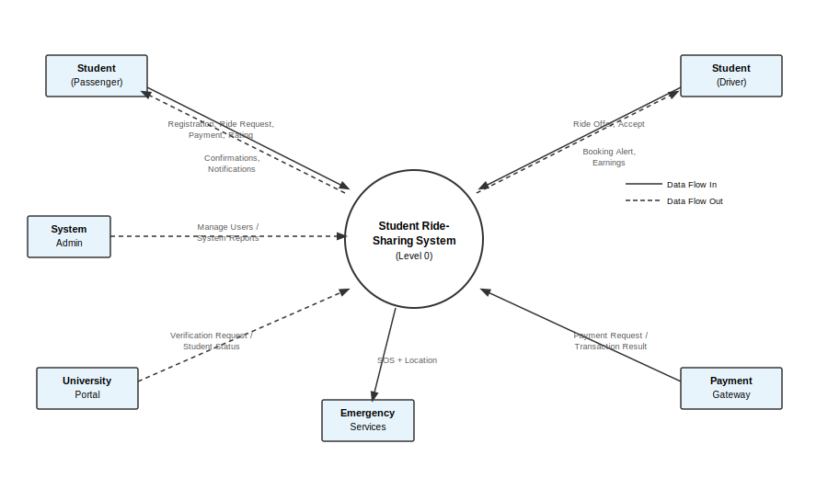
Figure 1: Context Level DFD — Student Ride-Sharing System

2.2 Level 1 DFD

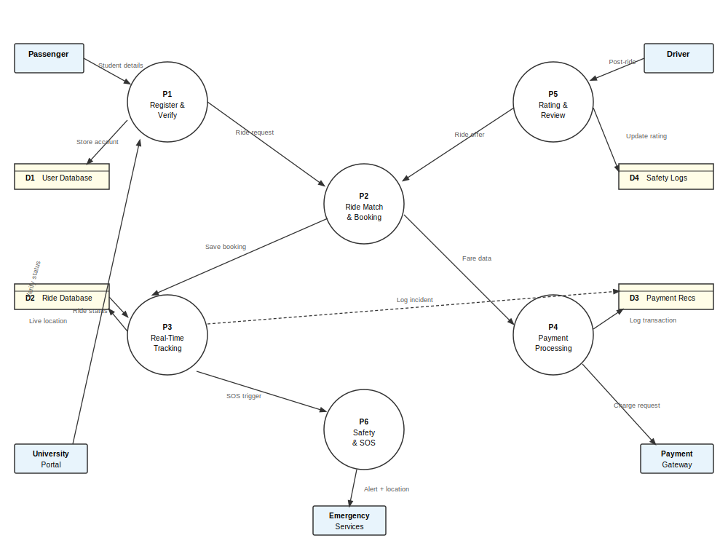
Figure 2: Level 1 DFD — Core Processes and Data Stores

Task 3: Actors and Use Cases
3.1 Actors

Actor | Description
Student (Passenger) | Verified university student who books rides, makes payments, and submits reviews.
Student (Driver) | Verified student who owns a vehicle and offers rides to fellow students.
System Administrator | Manages user accounts, handles disputes, monitors system performance and safety incidents.
University Portal | External system — provides student enrollment verification data.
Payment Gateway | External system — processes all financial transactions (JazzCash, EasyPaisa, cards).
Emergency Services | External entity — receives SOS alerts and live location data during safety incidents.

3.2 Use Cases

ID | Use Case | Primary Actor(s)
UC01 | Register Account | Student (Passenger / Driver)
UC02 | Verify Student Enrollment | System, University Portal
UC03 | Log In / Log Out | Student (Passenger / Driver)
UC04 | Offer a Ride | Student (Driver)
UC05 | Search & Book a Ride | Student (Passenger)
UC06 | Cancel a Ride | Student (Passenger / Driver)
UC07 | Track Ride in Real Time | Student (Passenger)
UC08 | Process Payment | Student (Passenger), Payment Gateway
UC09 | Split Fare Among Passengers | System, Student (Passenger)
UC10 | Rate & Review | Student (Passenger / Driver)
UC11 | Trigger SOS Alert | Student (Passenger / Driver), Emergency Services
UC12 | Manage User Accounts | System Administrator
UC13 | View Ride History | Student (Passenger / Driver)
UC14 | Earn & Redeem Loyalty Points | Student (Passenger / Driver)

Task 4: Use Case Model
The diagram below shows all actors, use cases, and their relationships including association lines, include, and extend relationships within the system boundary.

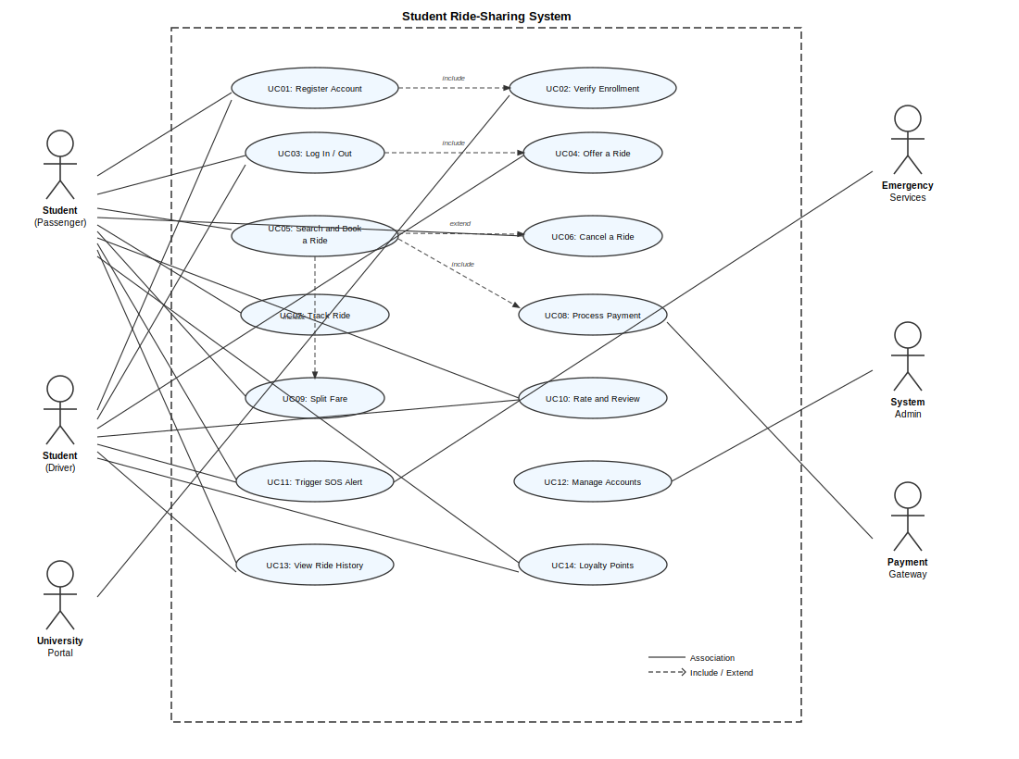
Figure 3: Use Case Diagram — Student Ride-Sharing Application

Task 5: Use Case Description — UC05: Search & Book a Ride
This use case is the most central operation in the system. It covers the full flow from a passenger searching for an available ride through to a confirmed booking.

Field | Details
Use Case ID | UC05
Use Case Name | Search & Book a Ride
Actor(s) | Student (Passenger) — Primary; System — Secondary
Description | A verified student searches for available rides to their destination and confirms a booking with a matching driver.
Preconditions | - Student is registered and verified.  - Student is logged in to the application.  - At least one driver has an active ride offer on the requested route.
Postconditions | - A confirmed booking record is stored in the Ride Database.  - Both the passenger and driver receive a booking confirmation notification.  - Payment is reserved and held until ride completion.
Main Flow | - Passenger enters pickup location and destination in the search form.  - System retrieves and displays matching available rides sorted by departure time and proximity.  - Passenger reviews ride details: driver profile, star rating, fare, available seats, and vehicle type.  - Passenger selects a ride and proceeds to the booking confirmation screen.  - System calculates the fare; if multiple passengers, fare is split equally.  - Passenger selects a payment method and confirms the booking.  - System reserves the seat, charges the payment method, and sends confirmation to both parties.
Alternative Flows | A1 — No rides available:  At step 2, if no matching rides exist, the system notifies the passenger. The passenger may modify the search parameters or schedule a future ride request.  A2 — Payment fails:  At step 6, if payment fails the system shows an error and prompts the passenger to choose another method. The booking is not confirmed until payment succeeds.
Exception Flows | E1 — Session timeout:  If the session expires mid-booking, the system clears the pending state and redirects to the login screen.  E2 — Seat fills before confirmation:  If another passenger books the last seat between steps 4 and 7, the system notifies the current passenger and returns them to search results.
Includes | UC08: Process Payment, UC09: Split Fare Among Passengers
Extended By | UC06: Cancel a Ride
Priority | High — Core functionality of the application

Task 6: Decision Table and Decision Tree — Paying Fare
The following decision table covers all condition combinations and resulting actions for processing fare payment. The decision tree after it shows the same logic in a visual branching format.

6.1 Decision Table

Conditions | R1 | R2 | R3 | R4 | R5 | R6 | R7
Ride completed successfully? | Y | Y | Y | Y | N | N | N
Payment method valid? | Y | Y | Y | N | Y | N | Y
Multiple passengers (split fare)? | Y | N | Y | — | — | — | —
Cancellation within 15-min window? | — | — | — | — | Y | — | N
Actions
Split fare equally among passengers | ✓ | — | ✓ | — | — | — | —
Charge full fare to single passenger | — | ✓ | — | — | — | — | —
Send payment receipt to all parties | ✓ | ✓ | ✓ | — | — | — | —
Credit earnings to driver wallet | ✓ | ✓ | ✓ | — | — | — | —
Prompt update of payment method | — | — | — | ✓ | — | — | —
Process full refund to passenger | — | — | — | — | ✓ | — | —
Mark ride as incomplete, no charge | — | — | — | — | — | ✓ | —
Apply cancellation penalty  fee | — | — | — | — | — | — | ✓
6.2 Decision Tree

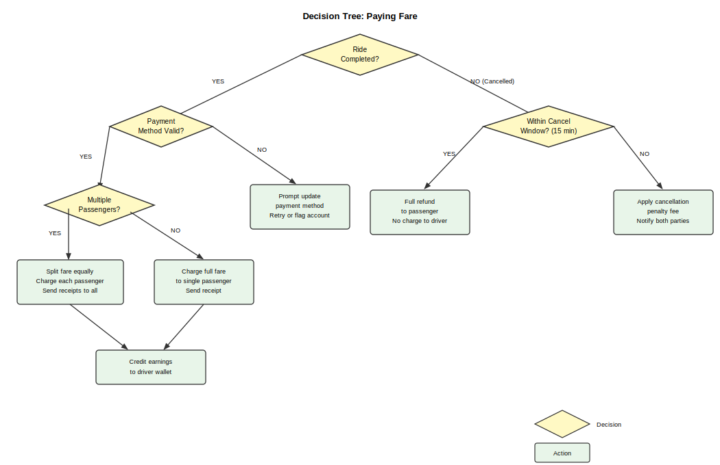
Figure 4: Decision Tree — Paying Fare

